As a kid born in the 1980s, I always knew who Bob Ross was, everyone does. The guy with the afro who paints "happy little clouds and trees.” But during my childhood I was too preoccupied with BMX bikes and Nintendo to sit around and watch a guy paint mountains for 30 minutes. Fast forward a few decades later to a wintery Saturday morning this past December. That morning on my TV channel guide I noticed the "Joy of Painting Bob Ross Channel" which plays episodes on constant loop. I decided to give it a shot as it felt like the perfect mindless TV I needed with my coffee before I get going on my weekend errands. That morning I became completely hooked on Bob painting his little rascal bushes and happy little clouds. The errands I was supposed to be doing were not happening. That morning I think I watched four or five episodes in a row of Bob Ross doing his magic. There's just something about his calm voice and unscripted musings while painting a golden yellow meadow. One musing that morning was about his one-on-one relationship with a neighborhood pet squirrel named Peapod that he adopted. At this point, I have now gone fully down the squirrel hole researching the life of Bob Ross and his paintings. Here's a link to a great Youtube video about Bob Ross' paintings from the New York Times.

The thing that inspires me most about Bob Ross is not so much his paintings, but his passion and dedication to his profession while asking very little in return. He did it because he loved painting and teaching others about the joy he had of painting. Over the course of twelve years Bob Ross would record 403 episodes, painting three near identical copies of each painting for each episode. One before the show to practice, one that aired during the show, and one after just for fun for a total of 1,200 or so odd paintings. They are likely worth millions, but he sold none of them. To this day most of them are stored in cardboard boxes in a small office warehouse in Virginia.

At this point, if you've made it reading this far, you're probably wondering what any of this has to do with ASCE Pittsburgh. Recently I had the opportunity along with several other members from ASCE Pittsburgh to attend the Multi-Regional Leadership Conference in North Carolina. While there I met engineers from all around the country and all walks of life in various stages of their careers. Many of whom reminded me of civil engineering versions of Bob Ross (minus the afro, unbuttoned shirt, and chest hair.) What I saw at the conference were professionals who have given countless unpaid volunteer hours to the civil engineering profession while asking very little in return from others. They are doing it because they love civil engineering, the society, and helping guide the next generation of young leaders in the name of advancing the profession.

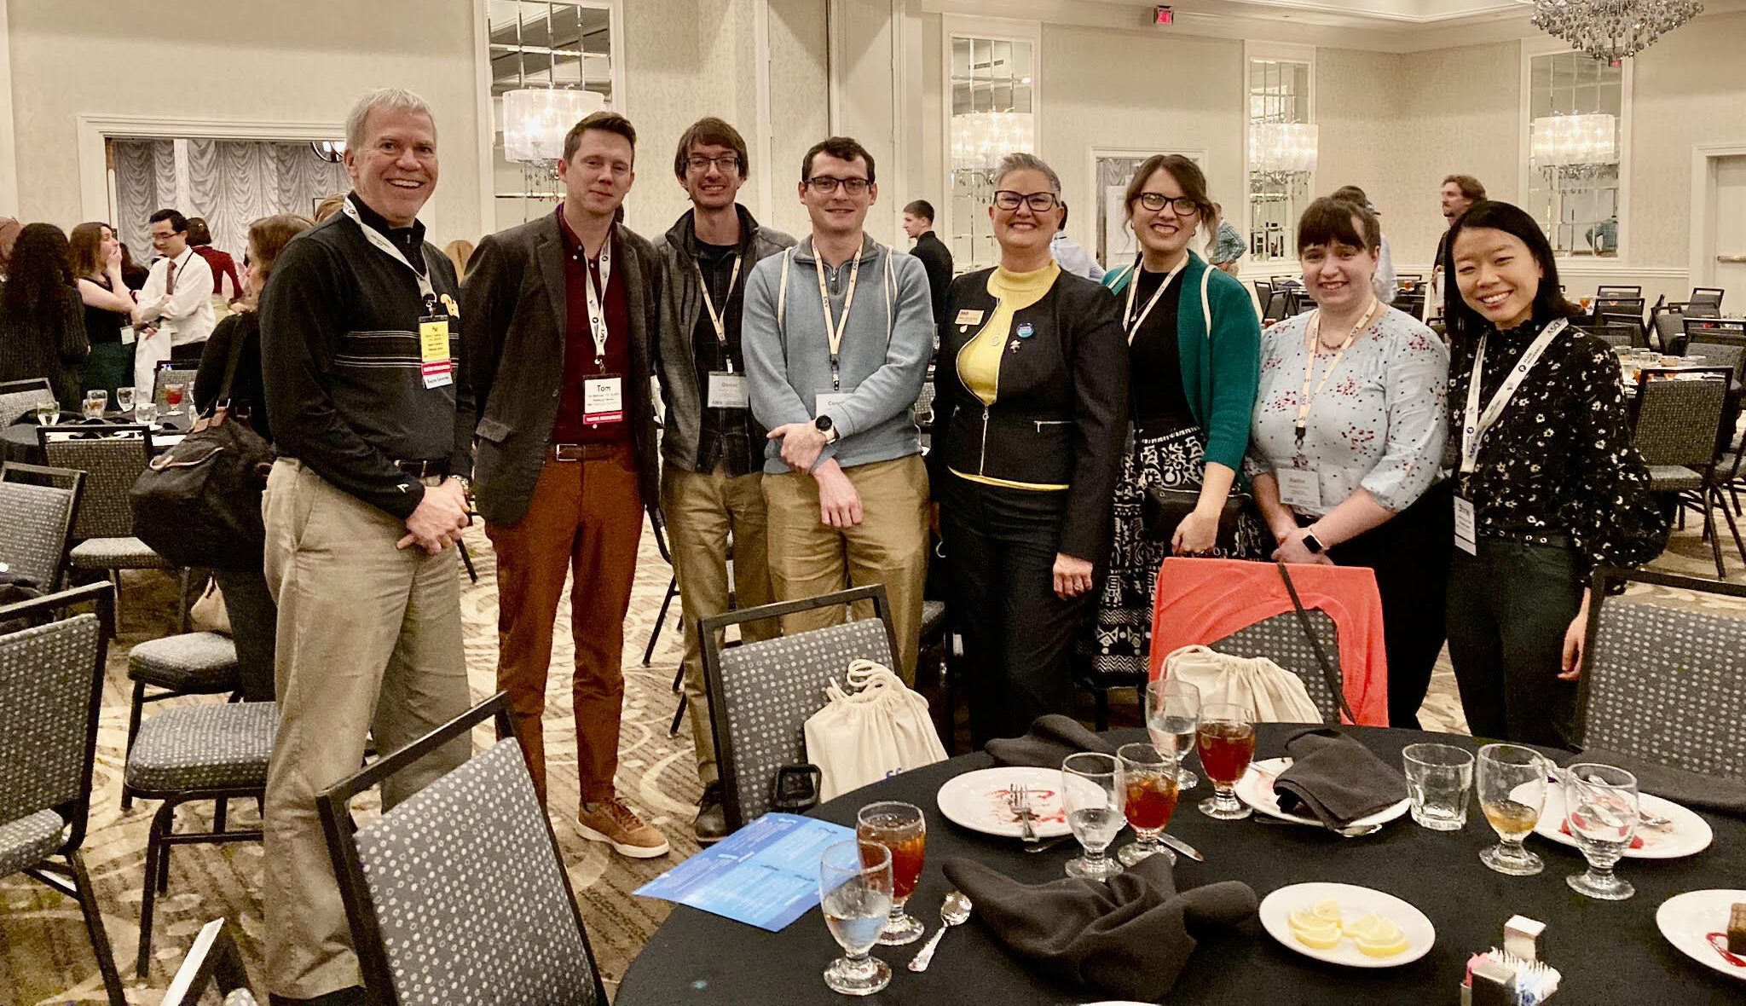
ASCE Pittsburgh Members and ASCE President Elect Marisa Geldert-Murphey (Pictured Left to Right: Pat Sullivan, Tom Batroney, Daniel Phillips, Connor Gibson, Marisa Geldert-Murphey, Jayne Marks, Katie DeOre, and Shirley Tang) Photo Credit: Pat Sullivan

During my career, I've come to realize one of the most rewarding aspects about being a civil engineer is volunteering my time at ASCE Pittsburgh. Finding ways to collaborate with others to host events, meeting with younger members, and presenting to student chapters. There's something very inspiring about interacting with other civil engineers who genuinely love the profession and ask nothing in return as well. Every so often I'll get to interact with a fellow colleague or younger member that will have a passion for a topic area or subject in their eyes much like when Bob Ross is painting his paintings. I realize that this President's message might sound a little bit corny to some, but so does repeatedly saying "here’s another happy little tree" over the course of 1,200 paintings and 403 episodes. Admittedly it is a bit ridiculous, but also realize those paintings are now worth millions and some are hanging on the walls of the Smithsonian in Washington DC. The reason they are hanging there are not because they are technical masterpieces but because of Bob Ross the person and his selflessness to his craft and others.

If you've ever considered becoming more active as a volunteer at ASCE Pittsburgh, you should absolutely do it. I'll never forget the year I moved to Pittsburgh and a senior engineer took me under his wing and got me involved at ASCE Pittsburgh and EWRI. If you're reading this, you know who you are! I'm thankful that happened because it helped open countless doors. If you're wondering how to get involved, the Section has several active local chapter technical institutes:
- Environmental & Water Resources Institute, (President: Cesar Simon)
- Structures Institute, (President: Brad Byron)
- Geo-Institute, (President: Taylor DaCanal)
- Transportation & Development Institute, (President: David DiGioia)
- Utility Engineering and Surveying Institute (President: Kate McKinley)
We also have numerous ASCE Pittsburgh committees:
- Younger Members Forum (President: Connor Gibson)
- Communications and Website (Erin Feichtner and Linda Kaplan)
- Educational Outreach (Shirley Tang and Ben Briston)
- Continuing Education (Justin Brooks)
- Justice, Equity, Diversity, and Inclusion (Darnetta Craig)
- Government Relations (Greg Scott)
- Membership (Bill Trimbath)
- Budget (Michael Krepsik)
- Student Awards Foundation (Angela Mayer)
- Programs (Pat Sullivan and Jonathon Shimko)
- Sustainability (Vacant - need help!)
- History and Heritage (Vacant - need help!)
We also directly interact with active ASCE student chapters at Carnegie Mellon University, Geneva College, Point Park University, Slippery Rock University, University of Pittsburgh, and University of Pittsburgh Johnstown.

If you are interested in volunteering your time in any of these groups or working more with the student chapters just respond to this email and we will get you in touch with the right person. Finally, I’ll end this message with a Bob Ross quote.

“Go out on a limb. That’s where the fruit is.” – Bob Ross

