Clean Water
Members,
In his June 1941 letter to the editor simply titled Stream Pollution to the Pittsburgh Bulletin Magazine, John E Koruzo, Member of the Special Committee on Sewage Disposal for Allegheny County, painted the following picture of Pittsburgh's ghastly river pollution at the time:
Allegheny County is a community distinguished because its sources of domestic and industrial water supplies are three large sewers called the Monongahela, Allegheny, and Ohio Rivers... 855,000,000 gallons of domestic sewage are cumulative at Pittsburgh's historic point every 24 hours, depositing 6,000 tons of organic solids along (their) beds.
Later on in his letter Mr. Koruzo would add the following stark reality of how river pollution was holding back Pittsburgh’s progress and quality of life:
The sludge accumulations on the beds of our streams range from 4 inches to four feet and are very much in evidence in low flow periods. Aside from aesthetic consequences, these sludge banks detract from general municipal appearances, interfere with water purification practices, cause heavy maintenance to municipal and private river improvements, allow no stream recreational facilities, increase river transportation operation costs, maintain constant sources of bodily infection, and lower marginal river real estate values.
The deplorable condition of Pittsburgh's rivers in the first half of the twentieth century seem almost unfathomable today, especially for those like me who were born after the passage of the Clean Water Act. It's hard to imagine pollution from industry and domestic sewage freely discharging into local streams and rivers 24 hours a day, 7 days a week, 365 days a year. To be fair it wasn't just Pittsburgh. Major rivers and streams throughout the nation were in a state of wretchedness due to pollution. The Cuyahoga River in Cleveland caught fire 13 times, at least once each decade, proceeding its most famous fire featured in an 1969 edition of Time Magazine. Likewise the same situation for the River Rogue in Detroit, the Schuylkill River in Philadelphia, Buffalo River in Buffalo, and Potomac River in Washington DC among many others. All these rivers were essentially open sewers and each caught fire in modern industrialized history.
The Federal Pollution Control Act of 1948 and its subsequent amendments often referred to as the "Clean Water Act" are perhaps the most important pieces of government regulations for drastically improving the quality of life for citizens in America and Pittsburgh. All one has to do is compare images of our rivers from yesteryear and today. Take a look at these comparative images of the Allegheny River looking towards the Strip District where once stood the historic Crucible Steel Company Works in the 1940s.
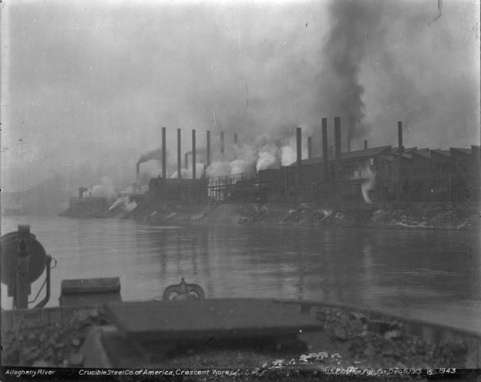
1940s Photo of Allegheny River Looking Towards the Strip District (Image From Historic Pittsburgh)
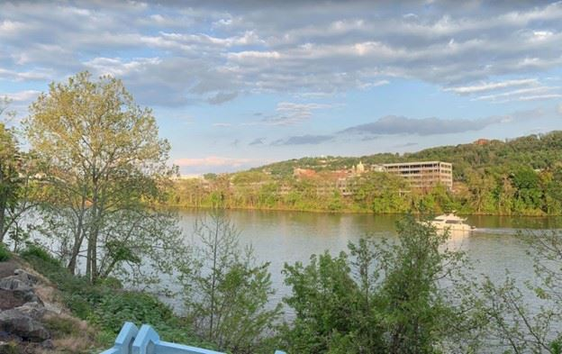
2022 Photo from Roughly the Same Vantage Point (Image From Google Street View)
This year on October 18th marks the 50th anniversary of the nation’s passage of the Clean of Water Act. In honor of this important milestone, ASCE Pittsburgh in partnership with regional water government agencies, nonprofit water related organizations, and area universities are hosting a free to the public Clean Water Festival in Millvale Riverfront Park. The festival will take place on October 15th from 11am to 3pm. We'll have food trucks, free giveaways, entertainment, water exhibitions, water expert panels and speakers, water themed artists, free rowing lessons, and activities for all ages. Together we are celebrating the progress we have made in cleaning up our rivers. We will also discuss the work that is left to be done to make them even cleaner.
It's hard to put into words within this short message just how important the Clean Water Act is to the civil engineering profession. It touches just about all disciplines in some form. As a civil engineering practitioner it's likely you've needed to cross a stream on a bridge or roadway project, or impact a wetland with a new pipeline, or design a sewage pump station to not overflow, or stabilize a stream bank, or install a new stream culvert, or permit a MS4 outfall, or design a treatment facility at an industrial or municipal plant. The list goes on. Thankfully we have the Clean Water Act to ensure that our rivers and streams are protected and the citizens of this nation no longer have to witness sludge filled rivers catching on fire.
I encourage everyone reading this message, ASCE members and non-members alike, to join us at the Clean Water Festival and bring your friends and families. It will be a day to remember and there will be something fun and educational for everyone. And be sure to stop by the ASCE booth and say hello!
Tom Batroney, PE, M.ASCE
ASCE Pittsburgh Section President
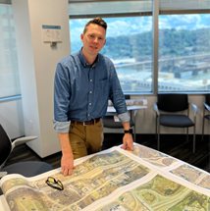

P.S. A big thank you to festival sponsors ALCOSAN, Evoqua Water Technologies, Michael Baker International, Sci-Tek Consultants, Wade Trim, AECOM, Brown and Caldwell, Colliers Engineering and Design, and the Departments of Civil and Environmental Engineering at Carnegie Mellon University and the University of Pittsburgh!!!
P.P.S. Please consider forwarding this message to co-workers, friends, and family! We would love to see as many people as possible at the festival!

