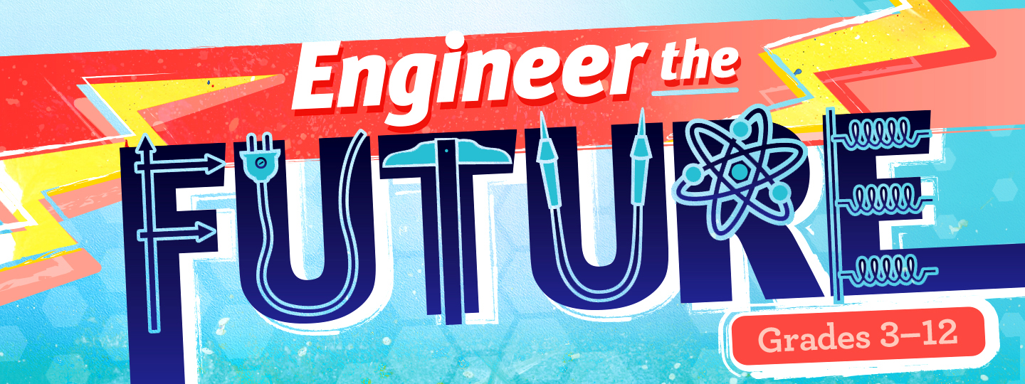

Virtual STEM Events Presenter Registration Form 2020

Name ________________________________________________________________
Email ________________________________________________________________
Organization __________________________________________________________
Official Title __________________________________________________________

I will participate in the following Virtual STEM Events (select all that apply):
☐ Engineer the Future (Grades 3-12), February 22-26, 2021

I will provide the following digital content (select all that apply):
☐ Prerecorded (15-30 Minute) Presentation
☐ Prerecorded (15-Minute) Demonstration
☐ Prerecorded (15-Minute) Facility/Department Tour
☐ Prerecorded (15-Minute) Career Conversation

Please provide a brief 2-3 sentence description of the content that you will be providing for inclusion in program materials (Examples: "Learn all about the science of polymers with Carnegie Science Center educators, and explore the power of polymers by creating your very own slime at home or in the classroom!" and/or "Dr. Smith, Professor of Chemistry at Carnegie Science Center University, studies metabolic pathways and cellular chemical reactions in iguanas. Learn more about their research and why/how they pursued a career in the field of chemistry.")
____________________________________________________________________________________________________________________________________________________________________________________________________________________________________________________________________________________________________________________________________________________________________________________________________________________________________
Please, save and send your pre-recorded content to Ms. Lorren Kezmoh at KezmohL@CarnegieScienceCenter.org as one of the following file formats: MP4, MPEG-4, FLV, WMV, MOV, or AVI. Recommended resolution and aspect ratios are as follows, 1080p: 1920x1080 and 720p: 1280x720.

Please return completed registration form, as well as your prerecorded content, to Ms. Lorren Kezmoh at KezmohL@CarnegieScienceCenter.org no later than Monday, February 1st, 2021 for Engineer the Future.

